車輛動態與控制
核心能力一 轉移函數之控制系統
- 何謂轉移函數?

$$T(s)=\frac{Y(s)}{U(s)}⇒Y(s)=T(s)⋅U(s)$$
- 何謂頻率響應?
Δ frequency Response：系統輸入為 正弦波 討論的Frequency輸出

Consider a linear time–invariant stable system G(S).
If the input is $A\text{sin}\text{wt}$, then the steady- state output is $B\text{sin}(\text{wt}+ϕ)$ where
$B=A\left|G(\text{jw})\right|$ , $ϕ\text{=∠}G(\text{jw})={\text{tan}}^{−1}\left[\frac{G(\text{jw})\text{的實部}}{G(\text{jw})\text{的虛部}}\right]$
Thus $G(\text{jw})=\left|G(\text{jw})\right|∠G(\text{jw})$
複數表示法 相量表示法
- 何謂波德圖?
Δ Bode Plot 波德圖

$$T(\text{jw})=\left|T(\text{jw})\right|∠T(\text{jw})≡M∠φ$$
As different from polar plot, Bode plots are sketched in two parts, namely the magnitude part and the phase part.
- Magnitude of $\left|G(\text{jw})\right|$ is drawn versus the frequency $w$
For convenience, the magnitude is plotted based on the logarithmic operator
(取log是為了方便相加)
∵ $\left|G_{1}(\text{jw})G_{2}(\text{jw})⋯G_{n}(\text{jw})\right|$$=\left|G_{1}(\text{jw})\right|\left|G_{2}(\text{jw})\right|⋯\left|G_{n}(\text{jw})\right|$
if we take logarithmic operation , then $\text{log}\left|G_{1}G_{2}⋯G_{n}\right|=\text{log}\left|G_{1}\right|+\text{log}\left|G_{2}\right|+⋯+\text{log}\left|G_{n}\right|$
which can be obtained by adding all the individual $\text{log}\left|G_{i}\right|$ together
- Phase of $T(\text{jw})=T(\text{jw})∠T(\text{jw})$,$φ\text{=∠}T(\text{jw})$
If $G(\text{jw})=G_{1}(\text{jw})G_{2}(\text{jw})⋯G_{n}(\text{jw})$
$$⇒∠G(\text{jw})\text{=∠}G_{1}(\text{jw})\text{+∠}G_{2}(\text{jw})+⋯\text{+∠}G_{n}(\text{jw})$$
By adding all$∠G_{i}(\text{jw})$ together, $∠G(\text{jw})$ is then obtained.

- 比例、微分、積分控制器之形式及特性為何?
控制器分類
R E Y
$$G_{C}(s)$$
$$G(s)$$
+
-

- 比例控制(proportional control)
$$G(s)=K_{P}$$
特性：
- 改善穩定度
- 改善穩態誤差
- 降低靈敏度
- 抑制雜訊

- 微分控制 (derivative control)
$$G(s)=K_{D}S$$
特性：
- 改善穩定度
- 提升響應速度
- 增加雜寬
- 放大雜訊 (x)

- 積分控制 (integral control)
$$G(s)=\frac{K_{I}}{S}$$
特性：
- 增加系統type消除穩態誤差
- 降低響應速度 (x)
- 易造成系統不穩定 (x)
- 比例+微分 $(P_{D})$
$$G(s)=K_{P}+K_{D}S$$

- 比例+積分 $(P_{I})$
$$G(s)=K_{P}+\frac{K_{I}}{S}$$

- 比例+積分+微分 $(P_{\text{ID}})$
$$G(s)=K_{P}+K_{D}S+\frac{K_{I}}{S}$$

例題 1:
When the system shown in the Figure 1-(a) is subject to a unit step input the
system output responds as shown in Figure 1－(b) Determine the values of T and K from the response curve.
Figure 1-(a)
例題 2:
Estimate the transfer for the” Bode plot” for the magnitude shown in the figure. Assume it is minimum phase.
$$G(s)=\frac{K\left(s+2\right)}{\left(s+2\right)\left(s+\text{10}\right)\left(s+\text{30}\right)}$$
$G(0)=\frac{0\text{.}2K}{2×\text{10}×\text{30}}=1$ ∴ K=3000
∵$\text{20}\text{log}1=0$dB
$\left|s\right|=1$
∴ $G(s)=\frac{\text{3000}\left(s+0\text{.}2\right)}{\left(s+2\right)\left(s+\text{10}\right)\left(s+\text{30}\right)}$

例題 3:
A mechanical system is shown in Figure. The motion of mass M is small and is constrained by a spring with constant k and a damper with coefficient c. A rigid bar is used to connect the mass and the disk. The motion of the disk is constrained by a torsional spring with spring constant G. The inertia of the disk is J and the friction of the disk is negligible. Derive the transfer function of this system in which y is the output and f(t) is the input.
Sol:
The free body diagrams are shown below
The dynamic equation
$f−p−\text{ky}−c\overset{˙}{y}=M\overset{¨}{y}$..... (1)
$\text{pr}−Gθ=J\overset{¨}{θ}$ .............. (2)
Because of $θ=\frac{y}{r}$
(2)$⇒p=J\frac{\overset{¨}{y}}{r^{2}}+G\frac{y}{r^{2}}$ into (1)
$$⇒(M+\frac{J}{r^{2}})\overset{¨}{y}+c\overset{˙}{y}+(K+\frac{G}{r^{2}})y=f$$
Taking Laplace transforms and we can get the transfer function of the system
$$\frac{Y(s)}{F(s)}=\frac{1}{(M+\frac{J}{r^{2}})s^{2}+\text{cs}+(K+\frac{G}{r^{2}})}$$

例題 4:
例：Consider a system shown in Figure. Suppose $r(t)=\text{sin}(t+{\text{60}}^{∘})−2\text{cos}(2t−{\text{30}}^{∘})$ Find the steady- state response y(t)
重疊定理響應
Sol：
$$G(S)=\frac{Y(s)}{R(s)}=\frac{\frac{\text{10}}{s+1}}{1+\frac{\text{10}}{s+1}}=\frac{\text{10}}{s+\text{11}}$$
(1) $r(t)=\text{sin}(t+{\text{60}}^{∘}),w=1$ $\left|G(j1)\right|=\left|\frac{\text{10}}{j1+\text{11}}\right|=\frac{\text{10}}{\sqrt{\text{122}}}$
$∠G(j1)=−{\text{tan}}^{−1}\frac{1}{\text{11}}$ 虛 實
∴$y(t)=\frac{\text{10}}{\sqrt{\text{122}}}\text{sin}(t+{\text{60}}^{∘}−{\text{tan}}^{−1}\frac{1}{\text{11}})$
(2) $r(t)=−2\text{cos}(2t−{\text{30}}^{∘}),w=2$
$\left|G(j2)\right|=\left|\frac{\text{10}}{j2+\text{11}}\right|=\frac{\text{10}}{\sqrt{\text{125}}}=\frac{2}{\sqrt{5}}$
$$∠G(j2)=−{\text{tan}}^{−1}\frac{2}{\text{11}}$$
∴$y(t)=−\frac{4}{\sqrt{5}}\text{cos}(2t−{\text{30}}^{∘}−\text{tan}\frac{2}{\text{11}})$
⇒ the total response
$$y(t)=\frac{\text{10}}{\sqrt{\text{122}}}\text{sin}(t+{\text{60}}^{∘}−{\text{tan}}^{−1}\frac{1}{\text{11}})−\frac{4}{\sqrt{5}}\text{cos}(2t−{\text{30}}^{∘}−{\text{tan}}^{−1}\frac{2}{\text{11}})$$

核心能力二 狀態空間之控制系統
  - 系統之可控制性
狀態空間設計(State space design)

古典控制
U(s) Y(s)
轉移函數
G(s)
輸入
輸出

$$G(s)=Y(s)\begin{aligned}\frac{U(s)}{}\end{aligned}$$
近代控制
$$\begin{aligned}\overset{}{X}=\text{Ax}+\text{Bu} \\ Y=\text{Cx}+\text{Du}\end{aligned}$$
U(s) Y(s)

X:狀態變數$x=\begin{aligned}\left[x_{1} | \right]\left[x_{2} | \right]\left[⋮ | \right] \\ \end{aligned}$$\begin{aligned}A∈R^{n×n} \\ B∈R^{n×1} \\ C∈R^{1×n} \\ D∈R\end{aligned}$

例題: y(t)

M
k

β

$$Μ\overset{¨}{y}(t)+B\overset{˙}{y}(t)+\text{ky}(t)=u$$

轉移函數法：
$$\begin{aligned}({\text{MS}}^{2}+\text{BS}+k)Y(s)=U(s) \\ ∴\frac{Y(s)}{U(s)}=\frac{1}{{\text{MS}}^{2}+\text{BS}+k}\end{aligned}$$

狀態空間法：
$$\begin{aligned}令y(t)=x_{1}(t)\text{ , \{}\overset{˙}{y}(t)=x_{2}(t)\end{aligned}(\text{controllable canonical form})$$
$$\begin{aligned}{\overset{˙}{x}}_{1}=x_{2} \\ {\overset{˙}{x}}_{2}=\overset{¨}{y}=−\frac{k}{M}\text{y-}\frac{B}{M}\overset{˙}{y}+\frac{1}{M}u \\ =−\frac{k}{M}x_{1}−\frac{B}{M}x_{2}+\frac{1}{M}u \\ ⇒ \\ \end{aligned}\begin{aligned}\left[{\overset{˙}{x}}_{1} | \right] \\ \end{aligned}$$
狀態空間之控制器設計(Controller Design in State Space)

可控制性(Controllability)
$\begin{aligned}\overset{˙}{x}=\text{Ax}+\text{Bu} \\ y=\text{Cx}\end{aligned}$$\begin{aligned}x=\begin{aligned}\left[x_{1} | \right]\left[x_{2} | \right]\left[⋮ | \right] \\ \end{aligned} \\ \end{aligned}$$\begin{aligned}\text{若存在}u=−\text{kx} \\ =−\left[k_{1}k_{2}…k_{n}\right]\begin{aligned}\left[x_{1} | \right]\left[x_{2} | \right]\left[⋮ | \right] \\ \end{aligned} \\ \end{aligned}$
$$\begin{aligned}\text{使得}\overset{˙}{x}=(A−\text{Bk})x \\ \text{其中}A−\text{Bk}\text{之特徵值得以任意決定，則稱此系統可控制，}u\text{為系統之} \\ \text{狀態回授}(\text{state}\text{feedback})\text{控制器}\end{aligned}$$

條件：
控制性矩陣
$Q_{c}=\left[B\text{AB}A^{2}B⋯A^{n−1}B\right]$
若 $\text{Rank}(Q_{c})=n\text{則系統可控制或}\left|Q_{c}\right|≠0\text{亦可為判斷依據}$

  - 何謂狀態回授控制?
控制器設計

$\begin{aligned}\overset{˙}{x}=\text{Ax}+\text{Bu} \\ u=−\text{kx}=−\left[k_{1}k_{2}…k_{n}\right]\begin{aligned}\left[x_{1} | \right]\left[x_{2} | \right]\left[⋮ | \right] \\ \end{aligned} \\ \end{aligned}$
- 先決定控制閉迴路系統之理想極點或理想特徵值
- $$λ(A−\text{Bk})=\text{理想值}$$
$$\text{求出適當}k值$$

例題1: 一控制系統其狀態方程式如下:
如果控制器設計為
其中a、b 為常數。當此閉迴路控制系統為穩定時，求出a、b之範圍並以a為橫軸，b為縱軸，畫出a-b之關係圖。

例題2:
無摩擦
y(t)
m=1

- 定義狀態變數 $x_{1}=y,x_{2}=\overset{˙}{y}$ 以及輸出 y , 列出狀態方程式。
- 設計狀態回授控制器 $u=2r−\left[\begin{matrix}k_{1} & k_{2}\end{matrix}\right]\left[\begin{matrix}x_{1} \\ x_{2}\end{matrix}\right]$ 使得閉迴路特徵值為$−1±j$
- 將此系統以下列方塊圖表示

r
y
+- +-

Sol:

(1)
$\begin{aligned}m\frac{d^{2}y(t)}{{\text{dt}}^{2}}=u(t)⋅m=1 \\ \overset{¨}{y}=u,∵x_{1}=y,x_{2}=\overset{˙}{y} \\ {\overset{˙}{x}}_{1}=x_{2} \\ {\overset{˙}{x}}_{2}=u⇒ \\ \end{aligned}\begin{aligned}\left[{\overset{˙}{x}}_{1} | \right] \\ \end{aligned}$
(2)
$u=2r−\left[k_{1}k_{2}\right]\begin{aligned}\left[x_{1} | \right] \\ \end{aligned}$代入
$$\begin{aligned}\begin{aligned}\left[{\overset{˙}{x}}_{1} | \right] \\ \end{aligned} \\ \end{aligned}$$

$$\begin{aligned}\begin{aligned}\left|λ−1 | \right| \\ \end{aligned} \\ \end{aligned}$$
(3)
$\begin{aligned}u=2r−2x_{1}−2x_{2} \\ 2(r−x_{1})−2x_{2}\end{aligned}$
r
2
y
2S
u

$$\frac{1}{S^{2}}$$
+ +
- -

例題3:
Give a system $G(s)=\frac{4s^{2}+\text{25}s+\text{38}}{s^{3}+9s^{2}+\text{26}s+\text{24}}$, if the state space representation of the system is $\begin{aligned}\overset{˙}{x}=\begin{aligned}\left[−200 | \right]\left[0a0 | \right] \\ \end{aligned} \\ \end{aligned}$ 求$a$,b,g?
Sol:
$$\begin{aligned}G(s)=\frac{4s^{2}+\text{25}s+\text{38}}{s^{3}+9s^{2}+\text{26}s+\text{24}} \\ \frac{A}{s+2}+\frac{B}{s−a}+\frac{C}{s−b}\end{aligned}$$
$$\begin{aligned}s^{3}+9s^{2}+\text{26}s+\text{24}=(s+2)(s+3)(s+4) \\ a=−3,b=−4 \\ A=2B=1C=1 \\ g=\begin{aligned}\left[2 | \right]\left[1 | \right] \\ \end{aligned} \\ \end{aligned}$$

例題4:
例:
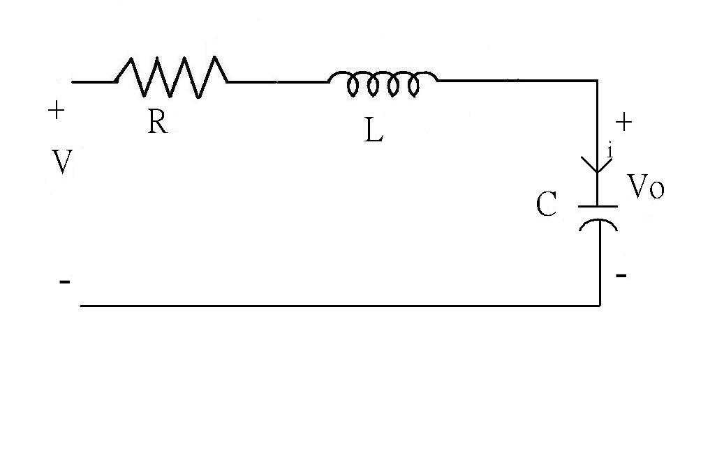
V為輸入電壓，V_{C}為輸出電壓
求狀態方程式及轉移函數

Sol：

電路方程式為
$$\begin{aligned}\left\{L\frac{\text{di}}{\text{dt}}+\text{Ri}+V_{C}=V | \right.\end{aligned}$$

轉移函數法(兩邊取拉式轉換)
$$\begin{aligned}(\text{LS}+R)I(s)+V_{C}(s)=V(s) \\ {\text{CSV}}_{C}(s)=I(s) \\ \left[(\text{LS}+R)\text{CS}+1\right]V_{C}(s)=V(s) \\ \frac{V_{C}(s)}{V(s)}=\frac{1}{\text{CS}(\text{LS}+R)+1}\end{aligned}$$

狀態空間法
令$V_{C}=x_{1}\text{ i}=x_{2}$
$$\begin{aligned}{\overset{˙}{x}}_{1}=\frac{1}{c}x_{2} \\ {\overset{˙}{x}}_{2}=−\frac{1}{L}x_{1}−\frac{R}{L}x_{2}+\frac{1}{L}V \\ ⇒ \\ \end{aligned}\begin{aligned}\left[{\overset{˙}{x}}_{1} | \right] \\ \end{aligned}$$

