動力學(Engineering Mechanics : Dynamics)

核心能力1：質點運動力學：能夠描述質點之加速度運動，並列出運動方程式。
- The 100-kg block A show in Fig.1. is released from rest. If the masses of the pulleys and the cord are neglected, determine the speed of the 20-kg block B in 2 s.
Fig.1
- The 17.5-kN automobile show in Fig.2 is traveling down the 10° inclined road at a speed of 6 m/s. if the driver jams on the brakes, causing his wheels to lock, determine how far s his tires skid on the road. The coefficient of the kinetic friction between the wheels and the road is μ_{k} = 0.5.
Fig.2

- The engine of the 1750-kg car is generating a constant power of 37.5 kW while the car is traveling up the slope with a constant speed. If the engine is operating with an efficiency of ε=0.8, determine the speed of the car. Neglect drag and rolling resistance.
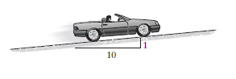
Fig.3

- The 15-Mg boxcar A is coasting at 1.5 m/s on the horizontal track when it encounters a 12-Mg tank B coasting at 0.75 m/s toward it as shown in Fig.4. If the cars meet and couple together, determine (a) the speed of both cars just after the coupling, and (b) the average force between them if the coupling takes place in 0.8 s.
Fig.4

核心能力2：剛體平面運動力學：能夠描述剛體之平面加速度運動，並列出運動方程式。

- The link shown in Fig.5 is guided by two block A and B, which move in the fixed slots. If the velocity of A is 2 m/s downward, determine the velocity of B at the instant θ = 45°.
Fig.5

- At a given instant, the cylinder or radius r, shown in Fig.6, has an angular velocity and angular acceleration. Determine the velocity and acceleration of its center G and the acceleration of the center point at A if it rolls without slipping.
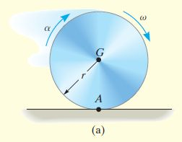
Fig.6

- The slender rod shown in Fig. 7 has a mass m and length l and is released from rest when $θ=0^{o}$. Determine the horizontal and vertical components of force which the pin at A exerts on the rod.
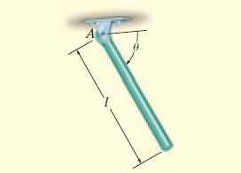

Fig.7

- The 25-kg wheel shown in Fig.8 has a radius of gyration k_{G} =0.2m. If a 50 N-m couple moment is applied to the wheel ,determine the acceleration of its mass center G. The coefficients of static and kinetic friction between the wheel and the plane at A are =0.3 and =0.25, respectively.
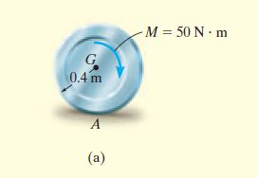
Fig.8

