核心能力: 學會電晶體運算

* + 電晶體的偏壓:
    - 電晶體的直流運算
    - 電路的電流及電壓運算
  + 電晶體的小訊號放大:
    - 電晶體的交流等效電路
    - 電路的交流勳號放大器設計及運算

1. 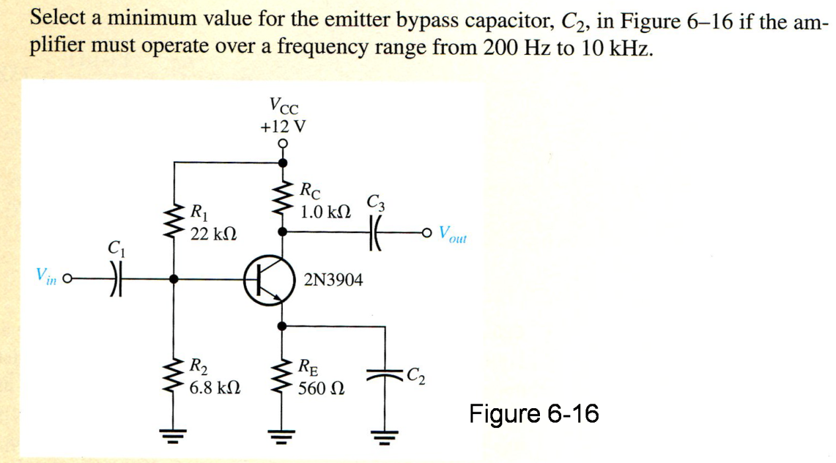

2.

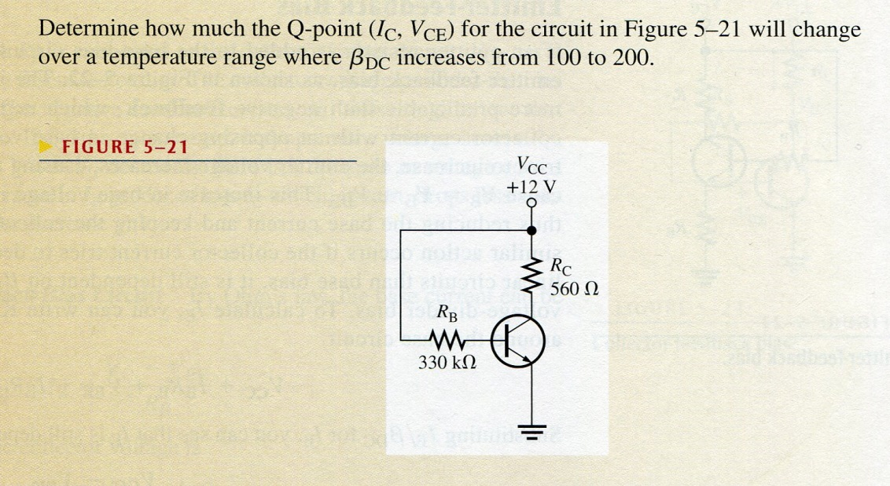

3. Determine the total input resistance of the emitter-follower in figure. Also find the voltage gain, current gain, and power gain in terms of power delivered to the load, . Assume and that the capacitive reactances are negligible at the frequency of operation.



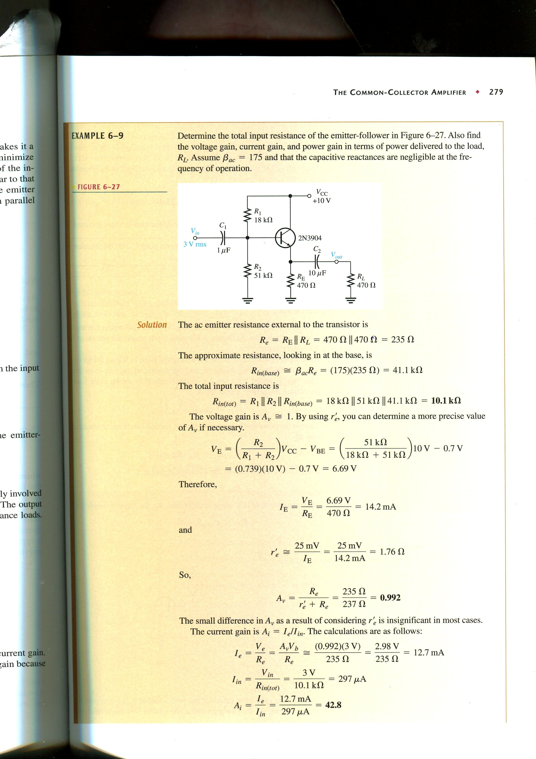

4 Determine the voltage gain of the following amplifer. It is known that , 0.2V. The capacitive reactances are negligible at the frequency of operation.



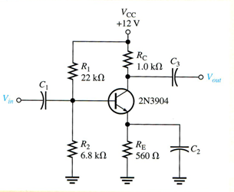

核心能力: 學會運算放大器運算

* + 運算放大器的基本特性:
    - 輸入電阻無限大
    - 開迴路增益無限大
    - …
  + 運算放大器的應用::
    - 反相及非反相放大器
    - 微分器、積分器及其他應用

1. 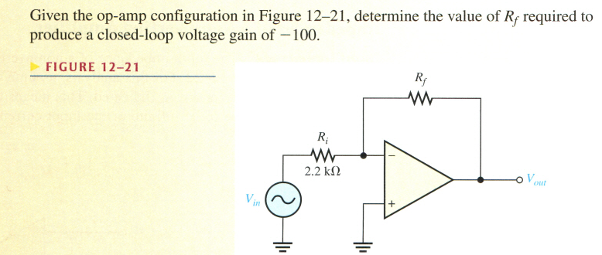

2. Determine the output voltage of the following circuit.

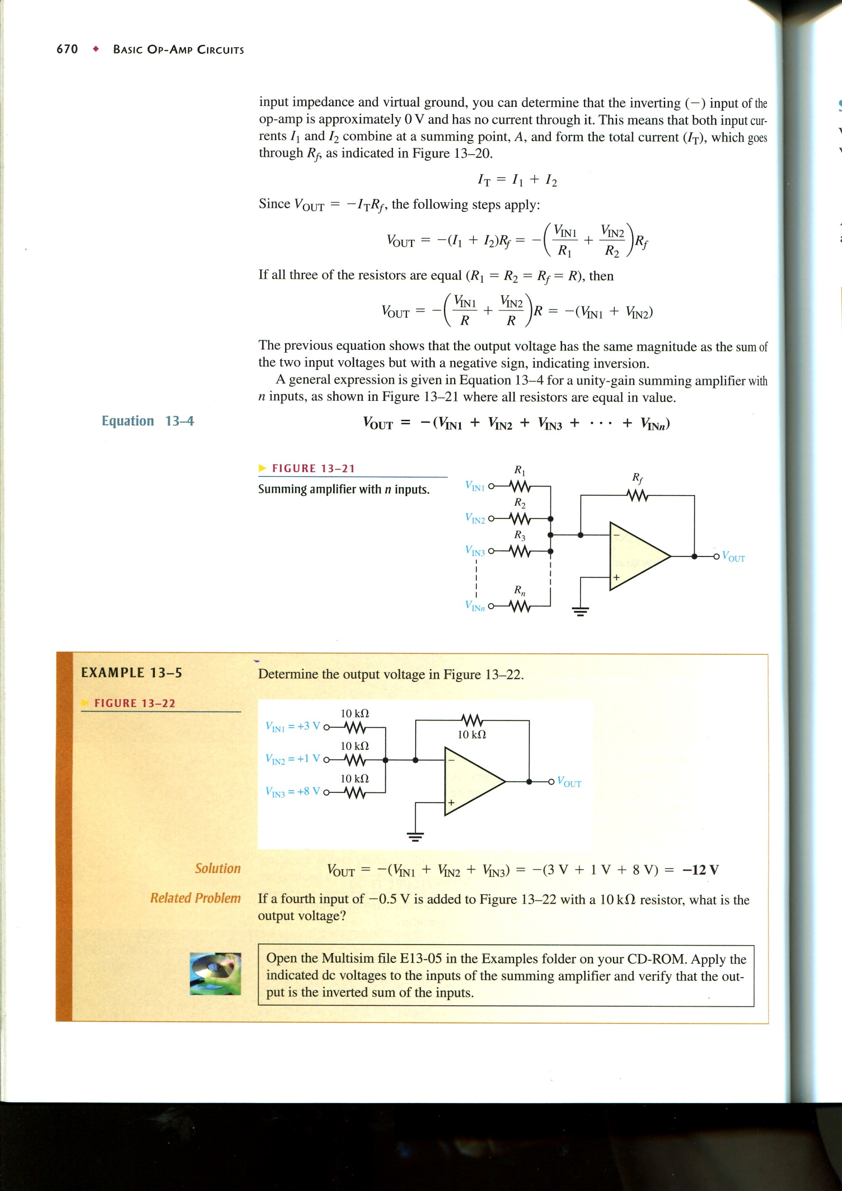

1. 試算出 *vo* 值為何？

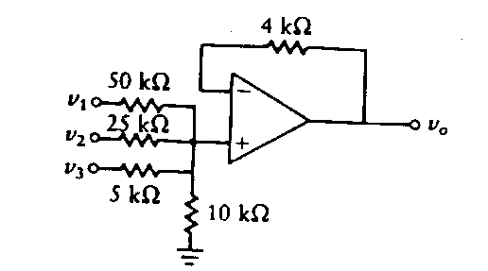

1. (Hint: ) , Determine *v*o(*t*) 35%

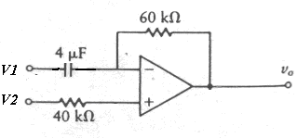(不能套公式，用推導的)